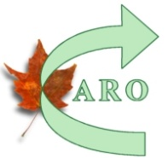Canadian Association of Rally Obedience
Association Canadienne de Rallye Obéissance Obéissance
Registering a Complaint/ L'enregistrement d'une plainte

Submitted by:  Summis par: | DATE:
Name/Nom:
Address: City/Ville
Prov: Postale code

Telephone: Email/Courriel:
Member # if Applicable ( # Membre si applicable)
Membership Type/Adhesion classe : Professional Associate Regular
x

Description of Offence Please describe the event that took place.  Description de l'infraction. Veuillez décrire l'événement qui a eu lieu. |  |  |  | Person who committed the Offence  Name required & contact information  Personne qui a commis l'infraction nom requis & informations de contact
Location

Name & Address of Witness
Nom et adresse du temoin
Signature of Witness (du temoin) ____________________________________
Signature of Person Filing the Complaint/ Signature de la personne déposant la plainte _____________________________

